## Designing a Publishing Site

**Lab Time**: 45 minutes

### Exercise 1: Creating a New Publishing Portal

In this exercise you will begin working with the Publishing Site Collection. This will give you an opportunity to experience the similarities and differences between the branding of publishing sites and the branding of team sites. You will customize the look and feel of the Publishing Site Collection to implement the public Website for Wingtip Toys.

1. Using the browser, navigate to the Publishing Site Collection using the URL that was provided to you. Throughout these lab exercises the student manual will refer to this URL as **http://[[PUBLISH-SITE]]**. However, the URL that you will use is unique to you, and will look something like this:

http://studentlabs.criticalpathtraining.com/sites/11062725-0PUBLISH-BD9B6

1. Once you navigate to the Publishing Site Collection, you should be able to see the home page of the top-level site in the browser. Note that you should initially be accessing the site using anonymous access and the **Site Actions** menu should not be visible. You should be able to see a **Sign In** link on the top right-hand side of the page.

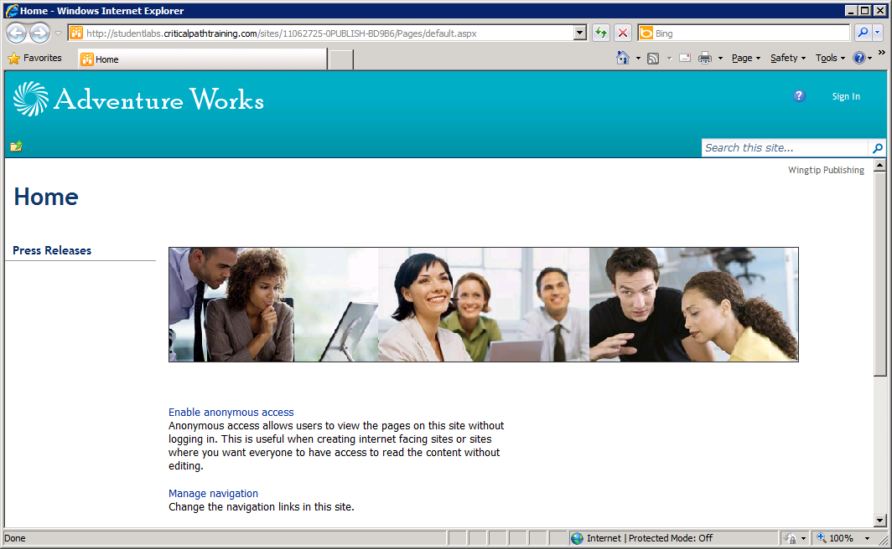

1. Click the **Sign In** link on the top right of the page to authenticate. Log in using the credentials of the site collection owner in the format of **[[AD-DOMAIN]]\[[USERNAME]]**. For example, if you were supplied the login credentials for Ken Sanchez with a user account name of **ken** and a domain name of **SBO,** then theaccount name for logging in should be entered as **SBO\ken**. The password for all accounts should be set to **Password1**.

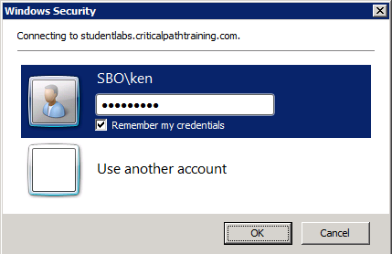

1. After being authenticated, you should now see the **Site Actions** menu.

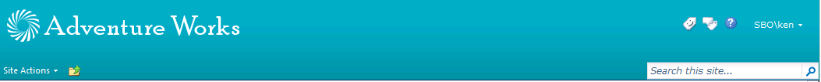

1. On the home page you should be able to observe that the ribbon is not currently visible, even though you are signed in as the site collection owner. The ribbon is hidden by default and you have to run a command to make it visible. Drop down the **Site Actions** menu and click the **Show Ribbon** menu command.

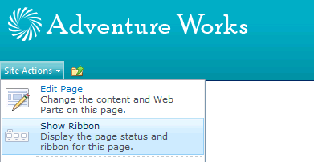

1. The ribbon should show up with the **Browse,** **Page** and **Publish** tabs.



1. Since you do not need the ribbon at the current time, hide it by dropping down the **Site Actions** menu and clicking the **Hide Ribbon** menu command.
2. Now it is time to get an overview of the high-level structure of sites and pages in the current Publishing site collection. Drop down the **Site Actions** menu and click the menu command with the caption of **Manage site content and structure**. You should now see the **Site Content and Structure** page as seen in the following screenshot.

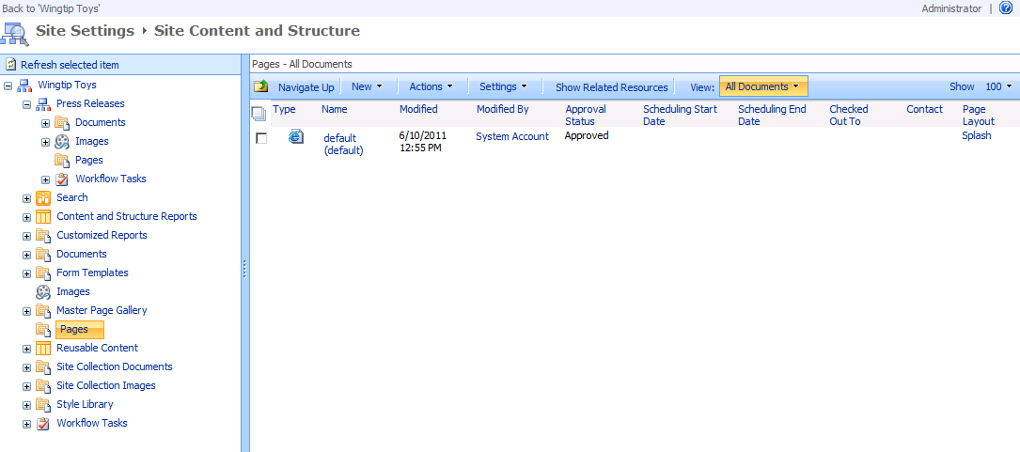

1. You will notice that the of **Manage site content and structure** page looks a bit odd because it still has the older SharePoint 2007 branding applied. You will also notice that once you navigate to this page, it can be tricky to get back to other pages in the site. Click the back button in the browser to go back to the home page of the site.
2. As a final task in Exercise 1, you will configure security so the user account you are using has permissions to approve content. This can be confusing because you are currently logged in as a site collection owner so you might assume you need no other permissions. This is not the case within a Publishing site collection. You will not have the proper permissions to approve sites and pages unless you explicitly add your user account (**[[AD-DOMAIN]]\[[USERNAME]]**) to the **Approvers** security group. The next few steps walk you through the process of accomplishing this.
3. Drop down the **Site Actions** menu and click the **Site Permissions** menu command to navigate to the Permissions page for the top-level site.

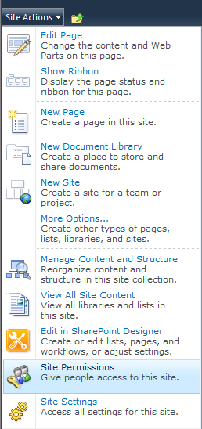

1. From the **Edit** tab in the ribbon of the **Permissions** page, click the **Grant Permissions** button.

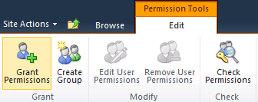

1. A dialog box should appear which allows you to configure permissions. Enter the current user named **[[AD-DOMAIN]]\[[USERNAME]]** and grant permissions to the **Approvers** group. Click the OK button to save your changes.

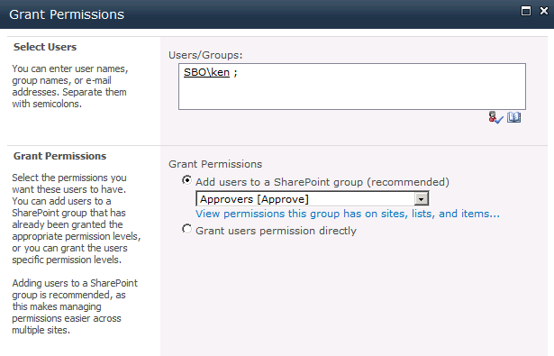

1. Your user account should now be properly configured as a member of the **Approvers** group which will make it possible for you to properly approve sites and pages later in this lab.

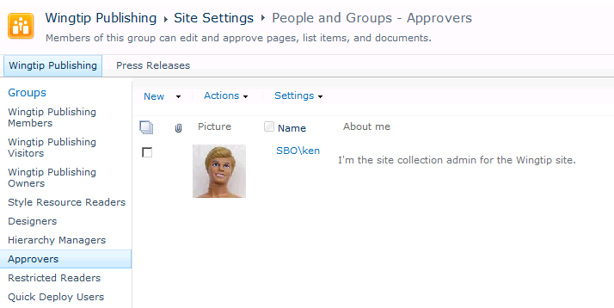

### Exercise 2: Configuring the Site Master Page and System Master Page

1. From the home page of the top-level site, drop down the **Site Actions** menu and select the **Site Settings** menu command, which will take you to the **Site Settings** page.

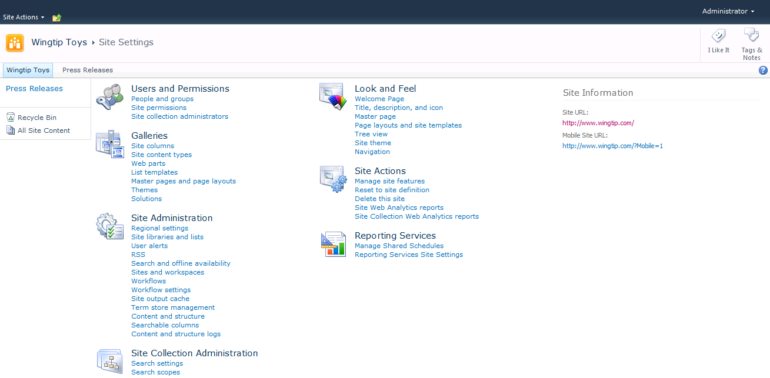

1. On the Site Settings Page, click the **Master page** link in the **Look and Feel** section to navigate to the **Site Master Page Settings** page. Currently the **Site Master Page** is set to **nightandday.master**. Using the drop down, change the selection to **v4.master**. Also check the checkbox with the caption **Reset all subsites to inherit this master page setting**. Click the **OK** button at the bottom of the page to save your changes. This will have the effect of changing the master page for all the publishing pages through the entire site collection. Remember that publishing pages are those pages that exist within the **Pages** document library.

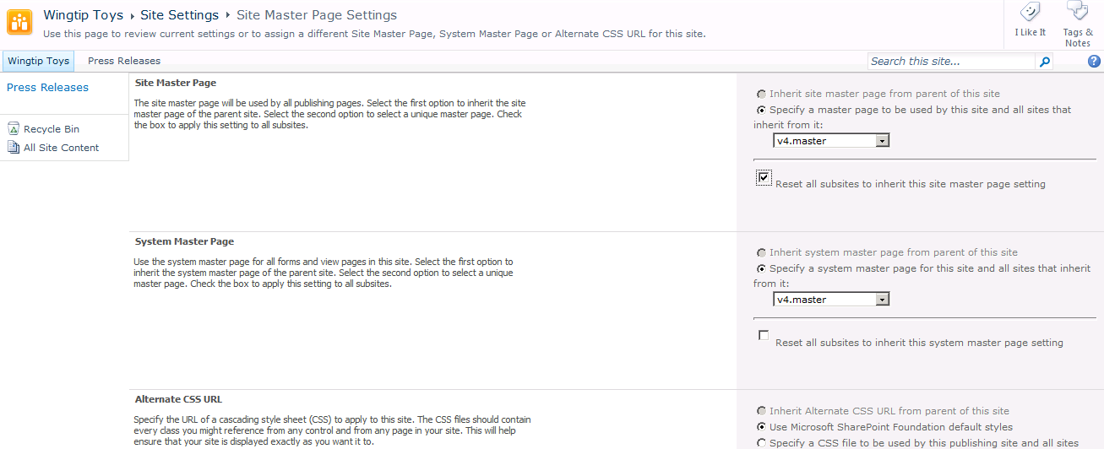

1. Click the **Adventure Works** link in the global navigation control to get back to the home page of the top-level site. You should see the site now uses the standard **v4.master** master page.

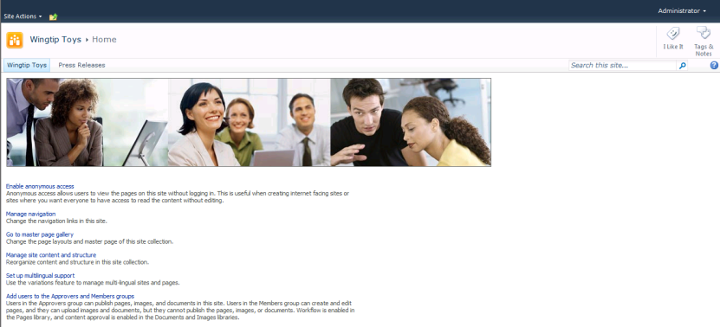

1. Now you are going to configure the System Master page setting that will affect all pages that are not publishing pages. In other words, this will affect all pages that are not inside the **Pages** document library. Drop down the **Site Actions** menu and select the **Site Settings** menu command that will take you to the **Site Settings** page. On the Site Settings Page, click the **Master page** link in the **Look and Feel** section to navigate to the **Site Master Page Settings** page.
2. Currently the **System Master Page** is set to **v4.master**. Using the drop down, change the selection to **nightandday.master**. Also check the checkbox with the caption **Reset all subsites to inherit this master page setting**. Click the **OK** button at the bottom of the page to save your changes.
3. You should notice that the **Site Settings** page is now rendered using **nightandday.master** instead of **v4.master**. In fact every page in the entire site collection with the exception of publishing pages will now be rendered using **nightandday.master**.

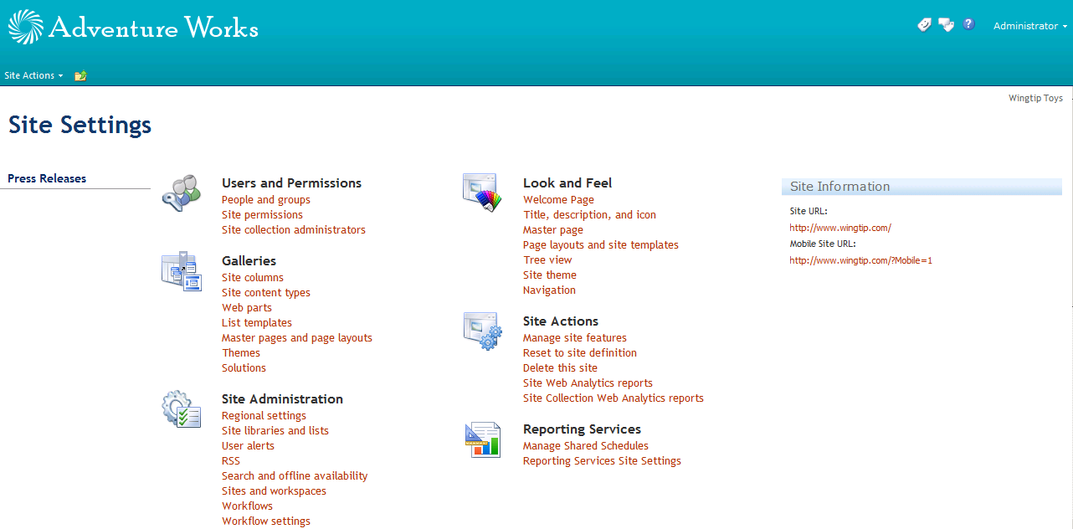

1. As a final step, reconfigure all pages in the current site collection to use **v4.master** as their master page instead of **nightandday.master**. Accomplish this byreturning to the **Site Master Page Settings** page. Make sure that both the **Site Master Page** setting and the **System Master Page** setting are configured to use **v4.master**. Also make sure to check the checkbox with the caption **Reset all subsites to inherit this master page setting**. Click the **OK** button at the bottom of the page to save your changes. Now all pages in the site should be rendering using **v4.master**.

### Exercise 3: Adding Content to the Publishing Site

1. In this exercise you will activate a special feature that will add more content to your publishing site collection. Start by navigating to the **Site Settings** page. On the **Site Settings** page, click the **Site collection features** link in the **Site Collection Administration** section.

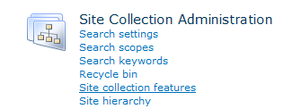

1. On the Site Collection Features management page, you should see a Feature with a special icon and a title of **CPT Web Designer – Feature for Generating Wingtip Content in Publishing Site Collection**. Activate this feature. Note that this feature will take about 20-30 seconds to complete its activation and add new content to the site.

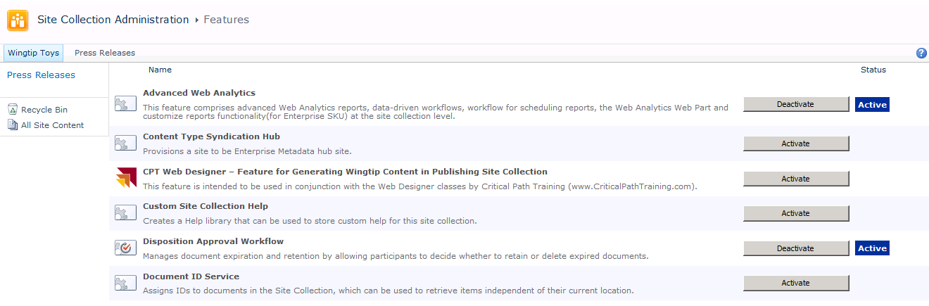

1. Once the feature has completed the activation process, the site collection should now have a much richer set of content. More specifically, the **Press Releases** site has been deleted and there are two new child sites named **Locations** and **Products**. The **Products** site has two child sites named **Planes** and **Trains**. Each if these sites contains several new publishing pages as well. Navigate back to the **Site Content and Structure** page and take a moment to examine the new structure of the site collection.

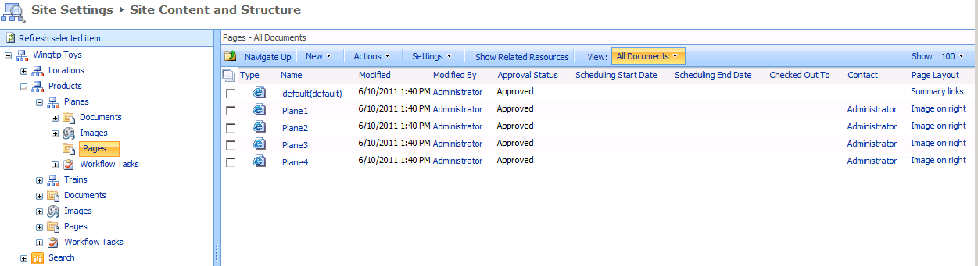

1. Now return to the home page of the top-level site and take a few minutes to navigate through the various sites and pages using the Global Navigation. Note that some -- but not all -- pages will display the Quick launch as well. That is because some of these publishing pages are configured with Page Layouts that intentionally hide the Quick launch bar.

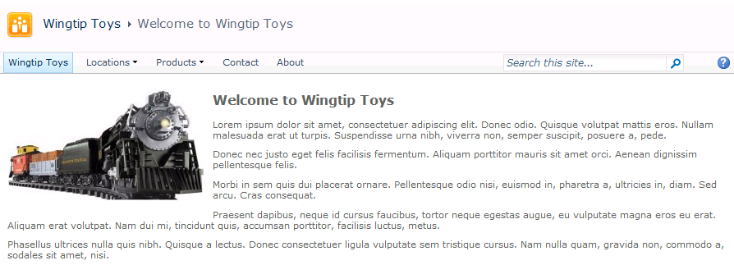

### Exercise 4: Uploading and Configuring Custom Master Pages

In this exercise you will upload two custom master pages along with the supporting CSS file and images. You will also move through the steps of publishing and approving these master pages and configuring the site collection to use them.

1. Open the browser and navigate to the folder at **c:\Student\Labs\Lab06_Publishing**. Inside you will find a child folder named **PublishingBrandingAssets**. Inside this folder there is a folder named **Master Pages** that contains two master page files named **Wingtip.master** and **WingtipNoQuickLaunch.master**.

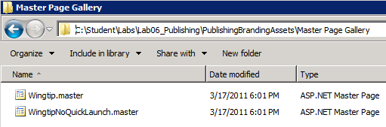

1. In the browser, navigate to the Master Page Gallery of the top-level site of the publishing site collection. Upload the two master pages named **Wingtip.master** and **WingtipNoQuickLaunch.master**. When you upload these files, you will be prompted to select a content type for each one. Make sure to set the content type of each master page file to **Publishing Master Page**.

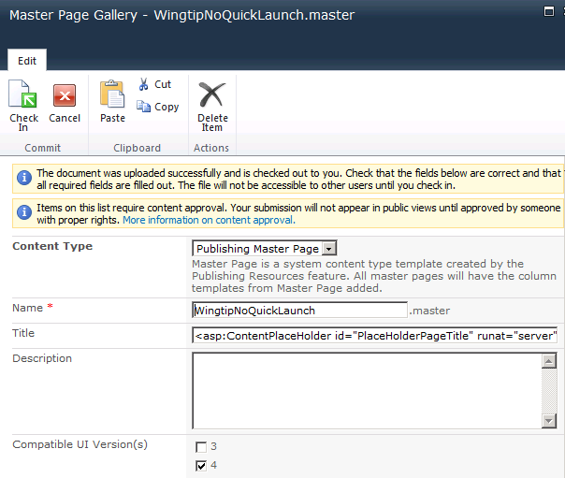

1. Once you have uploaded these two master pages to the Master Page Gallery, you must then publish and approve them before they can be used. Start by dropping down the ECB menu on each master page file and selecting **Publish a Major Version**. The next dialog asks you to add comments. You can leave the comments section blank and click OK to publish the master pages.

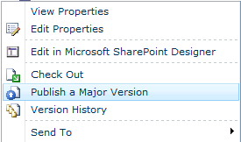

1. Next, use the ECB menu on each master page to invoke the **Approve/Reject** menu command.

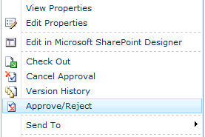

1. When you invoke the **Approve/Reject** menu item, you are prompted with the following dialog. Select the **Approved** radio button and click **OK** to approve both master pages.

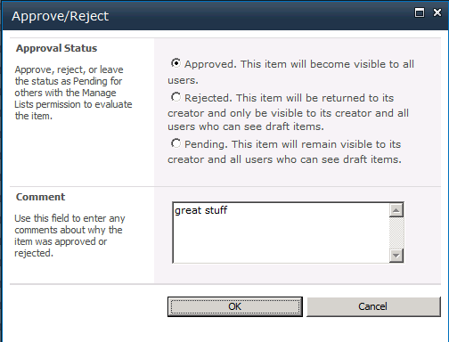

1. Return to the Windows Explorer inside folder for the lab and look inside the folder named **PublishingBrandingAssets**. You should see that there is a second folder named **Style Library** with an inner folder named **Wingtip**. Inside the **Wingtip** folder there is a CSS file named **WingtipMaster.css** and an **images** folder with images inside. In the next step, you will upload all these files to the Style Library.
2. In the browser, navigate to the **Style Library**. Create a folder at the root of the **Style Library** named **Wingtip**.

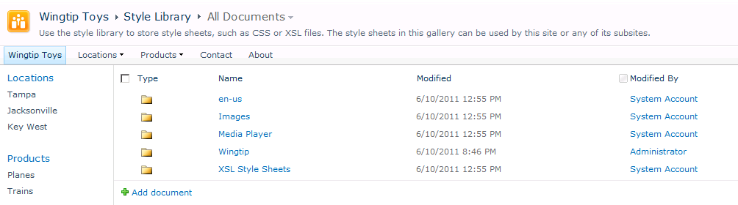

1. Navigate inside the new folder named **Wingtip** and then upload the CSS file named **WingtipMaster.css**. Once you have uploaded this CSS file, publish it as a major version. Note that you do not need to approve files inside the **Style Library** as you must do with master pages.

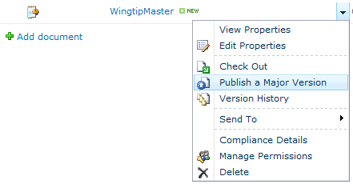

1. Inside the Wingtip folder, create a new child folder named **images**. Navigate inside the images folder and uploaded all the image files inside
2. Upload these files to the Style library and approve them. Make sure to upload the CSS file inside **c:\Student\Labs\Lab06_Publishing\Style Library\Wingtip\images**.
3. Next, you must publish each image file as a major version. Note that you can approve them all at once by selecting all of them in the **Content and Structure** page.

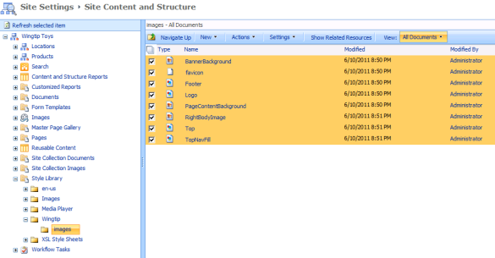

1. Once you have selected all the files, you can publish all of them at once using the **Publish** menu command in the **Actions** menu.

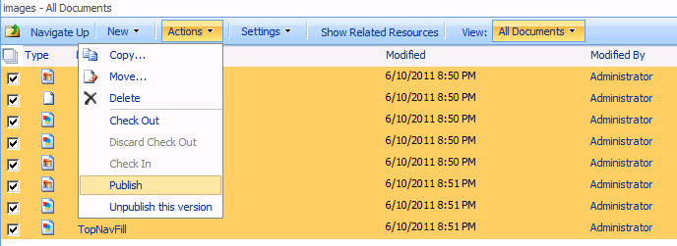

1. Now reconfigure the site collection to use **Wingtip.master** for all pages using the same steps you went through in Exercise 2 with the **Site Master Page Settings** page.

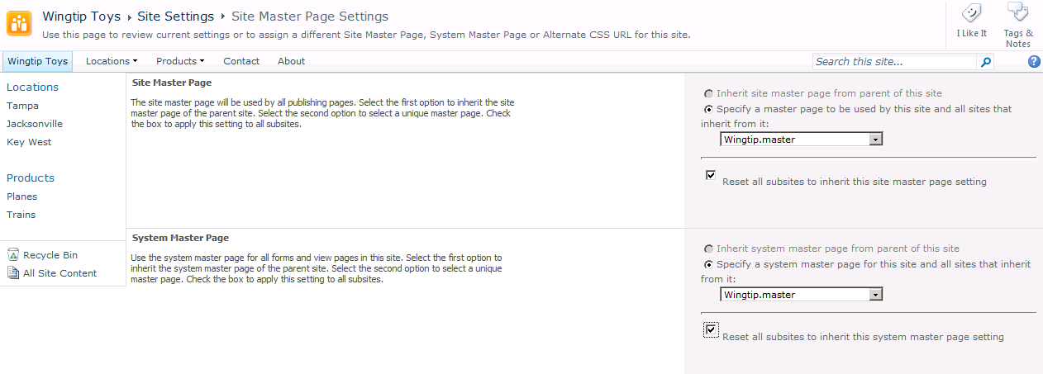

1. Once you have configured all pages in the site collection to use **Wingtip.master**, navigate around the site and see how the site looks with the new master page.

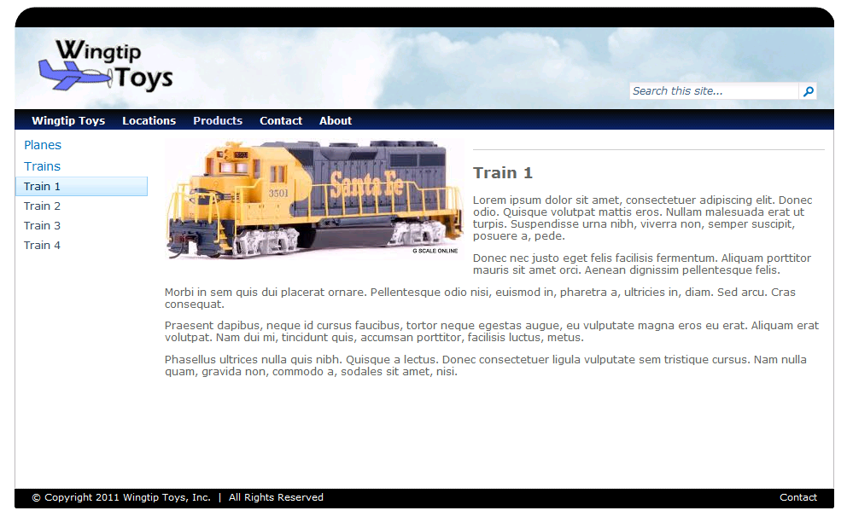

1. Now set the master page for the entire site collection to **WingtipNoQuickLaunch.master**. Navigate around the site and see how the site looks with the new master page that does not show the Quick Launch Bar.
2. If you feel like having even more fun, open either **Wingtip.master** and/or **WingtipNoQuickLaunch.master** in SharePoint Designer and continue to customize these master pages to your liking to change the HTML layout and branding for the pages in the publishing site.